Dosimetry is an essential tool used by radiation workers to ensure the Division of Radiation Safety (DRS) has an accurate record of the doses received from occupational radiation exposure at NIH, and that regulatory exposure limits are not exceeded by NIH workers. Proper handling and care are fundamental to ensuring exposure records are accurate:
- Dosimetry may consist of a Whole Body monitor, a Collar monitor, a Left and/or Right Ring dosimeter, or a Wallet dosimeter if a first responder.
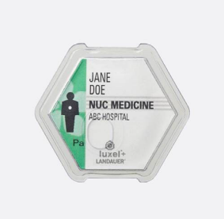
- Ensure you are wearing your assigned dosimetry anytime you are working with radiation sources. When your dosimeter is not in use, store dosimetry away from sources of ionizing radiation so that false doses don’t record.
HOW TO HANDLE:
- NEVER wear your dosimeter if you are undergoing a medical procedure. You are not considered a radiation worker during the time you are a medical patient, and any radiation exposure you receive is not meant to be included in your occupational dose history.
- NEVER share your dosimetry. If a colleague needs dosimetry, has lost their dosimeter, or contaminated their dosimeter and requires a replacement, contact DRS. A spare dosimeter can be issued promptly.
HOW TO OBTAIN:
Remember to remove the plastic tab on the dosimeter before inserting into the holder.
HOW TO WEAR:
- If you have a change in dosimetry Custodian, radiation worker status, dosimetry need, etc., contact the DRS Dosimetry Program as soon as is practical. Since dosimeters are printed in advance, it can take time to see the results for changing dosimetry or canceling dosimetry. Wear your Spare dosimeter until the pre-printed one is issued.
HOW TO WEAR:
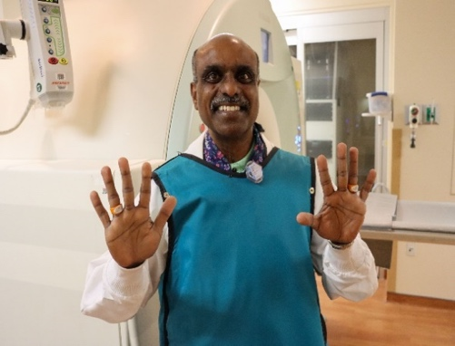
- Many x-ray workers wear a lead apron to shield themselves from prolonged radiation exposure. If issued two dosimeters, remember the CHEST dosimeter goes BELOW the lead, and the COLLAR goes ABOVE the lead apron. This is to ensure an estimate of your lens of the eye dose using the Collar dosimeter as the closest approximation. DO NOT MIX UP DOSIMETERS. If you are only assigned one dosimeter while wearing a lead apron, place the dosimeter above the apron.
TO GET YOUR DOSE:
- All individuals issued dosimetry will receive a copy of the previous year’s annual dose report in the Spring of each year.
- DRS will conduct prompt ALARA investigations if you exceed 10%, 30%, or 50% of your allowable dose limits. At doses above 70%, further radiation work is prohibited until the next tracking period.
Proper location to wear collar and finger rings.
- At any point in the year, you may request a copy of your Dose History by contacting DRS in writing. Your Dose History report will be sent to you. If employed at more than one site, provide the site name and a point of contact for each site if possible.
- When dosimetry is returned on time, the results for the dosimetry should be available in 4-6 weeks. You and your Custodian will be notified if your dosimetry is more than 45 days overdue, with a second reminder sent at 120 days.

- Return all used (or unused) dosimetry to DRS at the end of the assigned wear period when replacement dosimeters are received. Dosimeters are exchanged through a dosimeter Custodian who serves as the point of contact for DRS. Alternatively, mail or drop off to 21/116.
HOW TO EXCHANGE:

If you have any additional questions or concerns, contact DRS at dosimetry@mail.nih.gov or by phone at 301-496-5774.

